# 21BDS0340

# Abhinav Dinesh Srivatsa

# Electronics Lab

# Task 4

# Exercise No.: 1 Date: 09/04/22

Common Emitter Amplifier

**Circuit Diagram**

**Components Required**

Basic – Resistors, Capacitors

Sources – Power Sources – VCC, Ground, AC_Voltage

Transistors – BC547BP

Simulate – Instruments – Oscilloscope, Bode Plotter

**Simulated Circuit Diagram**

**

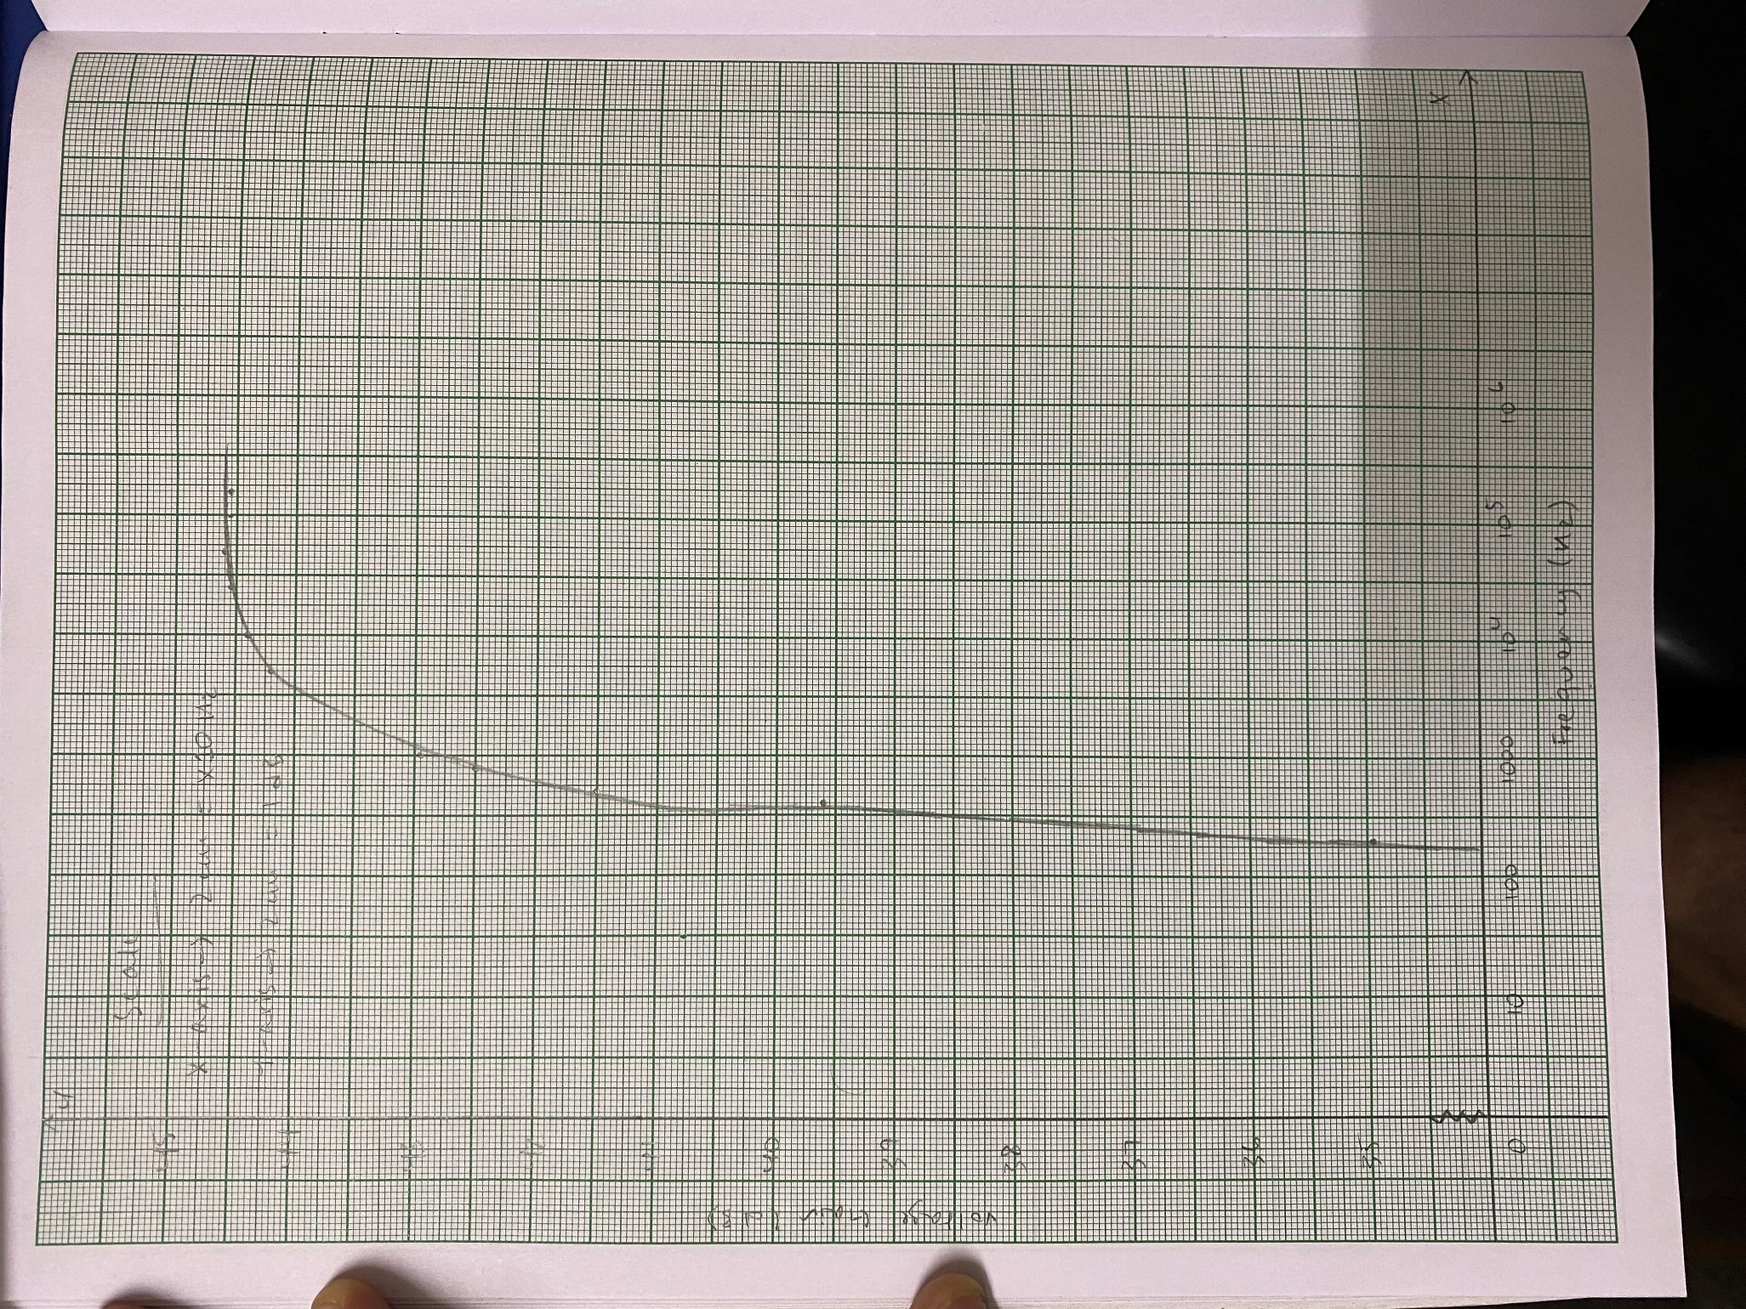**Graph**

**Calculations from Simulated Graph**

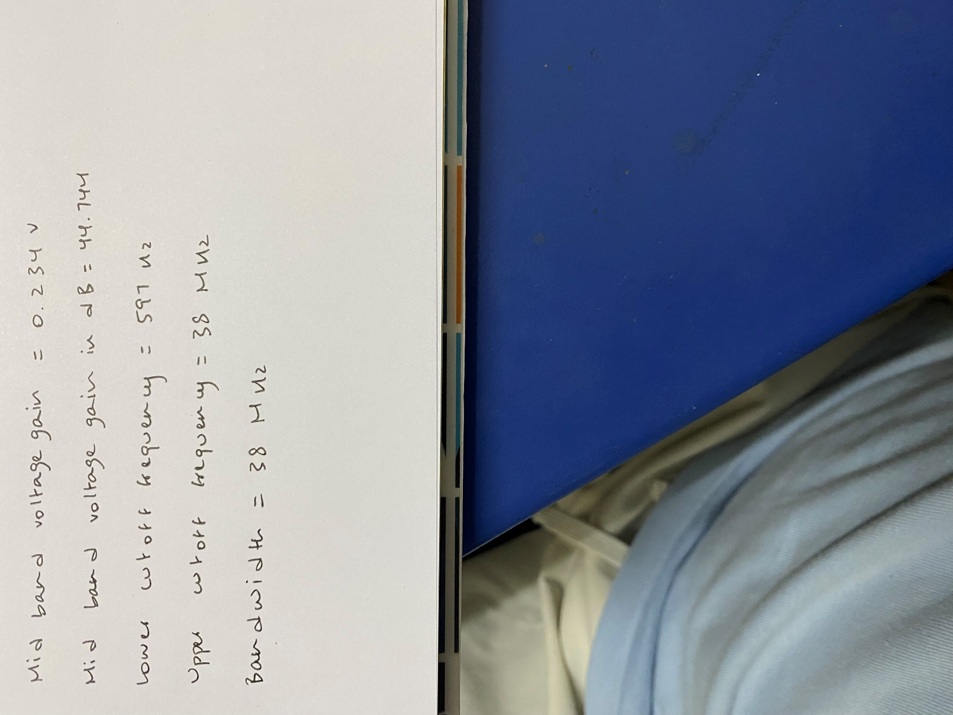

Verification Message

